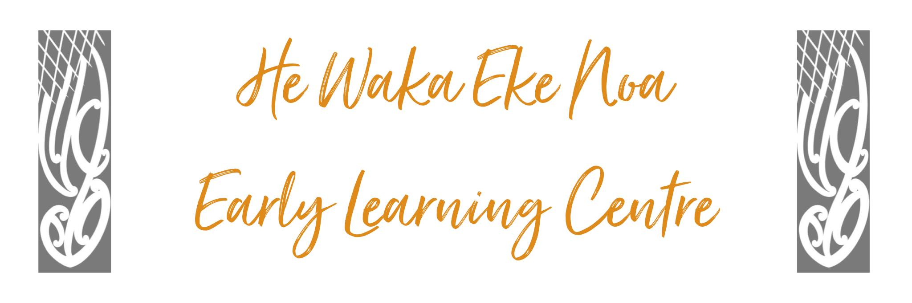

PHILOSOPHY

He Waka Eke Noa is a whanau-orientated community-based early learning centre. We embrace Whanaungatanga as one of our core values where interconnected, reciprocal and responsive relationships are celebrated.

We acknowledge each child reflects inherent dispositions of who they are and where they come from.
By acknowledging “Taonga tuku iho” attributes inherited from their tūpuna including, whanaungatanga, manaakitanga, kotahitanga, kaitiakitanga and rangatiratanga. We aspire to uplift and nurture each tamaiti.

Upholding mana throughout our approach to teaching and learning ensures tamariki are affirmed and respected. Our vibrant team of Kaiako are guided by the principles of Te Whāriki, we recognise tamariki as creative partners, authentic learners and capable problem solvers in a shared learning journey. They are committed to working alongside tangata whenua and tangata tiriti to celebrate and uphold the aspirations contained within Te Tiriti o Waitangi.

Aroha mai, Aroha atu, the give and take of life. Our nga mara (garden) and beautiful outdoor surrounding’s provide authentic opportunities for our tamariki and whanau as they journey to become kaitiaki of te taiao.
Our well-being and the well-being of te taiao is interconnected and the desire to be kaitiaki (nurturers, guardians) is a growing interest for our learning community.

As a team we continue to create a beautiful, inspiring space to celebrate, grow, support and empower one another.

He waka eke noa

A canoe which we are all in
with no exception

