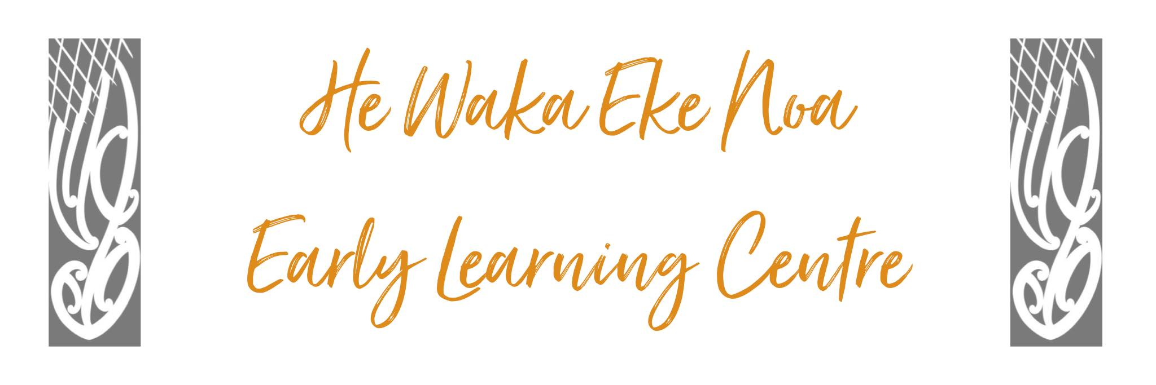

Carseat Safety Policy

Policy:
Under New Zealand law, all children under seven years of age must use an approved child restraint appropriate for their age and size.

Procedures:
- All tamariki arriving and departing He Waka Eke Noa Early Learning Centre must be restrained in an approved child restraint when travelling in a car.

- New Zealand Transport recommends the use of an appropriate child restraint (or booster seat) until your child reaches 148 cm tall or is 11 years old. Child restraint and medical professionals recommend that you keep your baby in a rear-facing restraint until as old as practicable, at least until they are 2 years of age

- When on an excursion where travel by car is required:

- each child is restrained as required by Land Transport legislation;
- required adult:child ratios are maintained; and
- the written permission of a parent of the child is obtained before the travel begins (unless the child is travelling with their parent)
- For more Information please visit: www.nzta.govt.nz

- Any complaints about breaches of this policy must follow the Complaints Procedure and be addressed to the Management Committee.

- This policy will be reviewed annually and in line with relevant legislation

Links to: Regulation 46 Health and Safety Practices & Criterion HS18

Date: | April 2023
Review Date: | April 2024
Consultation  Undertaken: | Staff/whanau/community

