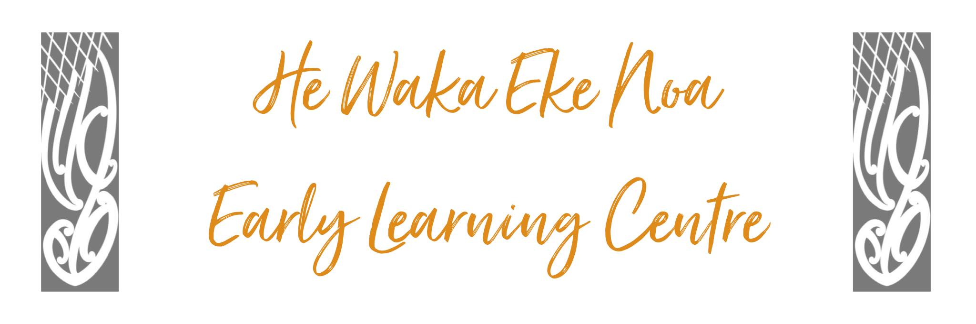

Curriculum Policy

Rationale

The Management Committee will ensure that the Curriculum available to children will meet all requirements of the New Zealand Early Childhood Curriculum Statement – Te Whaariki and the NELP’S (The Statement of National Education and Learning Priorities in New Zealand Early Childhood Services

Policy
The Management Committee will ensure that the curriculum enhances each child’s development and learning through

- Extending children’s thinking and actions through sensitive and informed guidance, interventions, and support
- Respect for children’s individual preferences; involvement of children in decision-making
- Planning and evaluation of the physical environment
- Provision of resources to support each child
- Facilitation of quality experiences and interactions
- Practice and promotion of non-discriminatory behaviour
- Implementation of inclusion strategies

The Management Committee will ensure that the service educators:
Can demonstrate knowledge and understanding of the following

- current theory and principles of learning and development
- the different characteristics of infant, toddlers and young children
- the learning and development of each child
- identification of learning goals for individual children as a basis for planning, evaluating and improving the programme

Can implement a curriculum which

    - reflects the holistic way children learn
    - reflects the reciprocal relationships between the child, people and the learning environment
    - involves parents/guardians and whanau
    - enhances children’s sense of themselves as capable people and competent learners
    - Reflects a partnership with Te Tiriti O Waitangi

The Management Committee will ensure that the service’s educators will develop, implement and evaluate a curriculum/programme
That:
    - Ensures children ‘s health is promoted,
    - Their emotional well-being is nurtured
    - They are kept safe from harm
    - Affirms and extends connecting links with family and the wider world
    - Children know they have a place and feel comfortable with routines, customs, and regular events
    - Children know the limits and boundaries of acceptable behaviour

That provides equitable opportunities for learning for each child irrespective of:
    - Gender
    - Ability
    - Age
    - Ethnicity
    - Background

Where:
- Children are affirmed as individuals

- Children are encouraged to work with and alongside others

- Children develop verbal and nonverbal communication skills for a range of purposes

- Children experience the stories and symbols of their own and other cultures

- Children discover and develop different ways to be creative and expressive

- Children’s play is valued as meaningful learning

- The importance of spontaneous play is recognised

- Children gain confidence and control of their bodies

- Children learn strategies for active exploration, thinking, and reasoning

- Children develop working theories for making sense of the natural, social, physical and material worlds.

Authorised: | Management Committee
Date: | Feb 2024
Review Date: | Feb 2025
Consultation Undertaken: | Staff/whanau/Management

