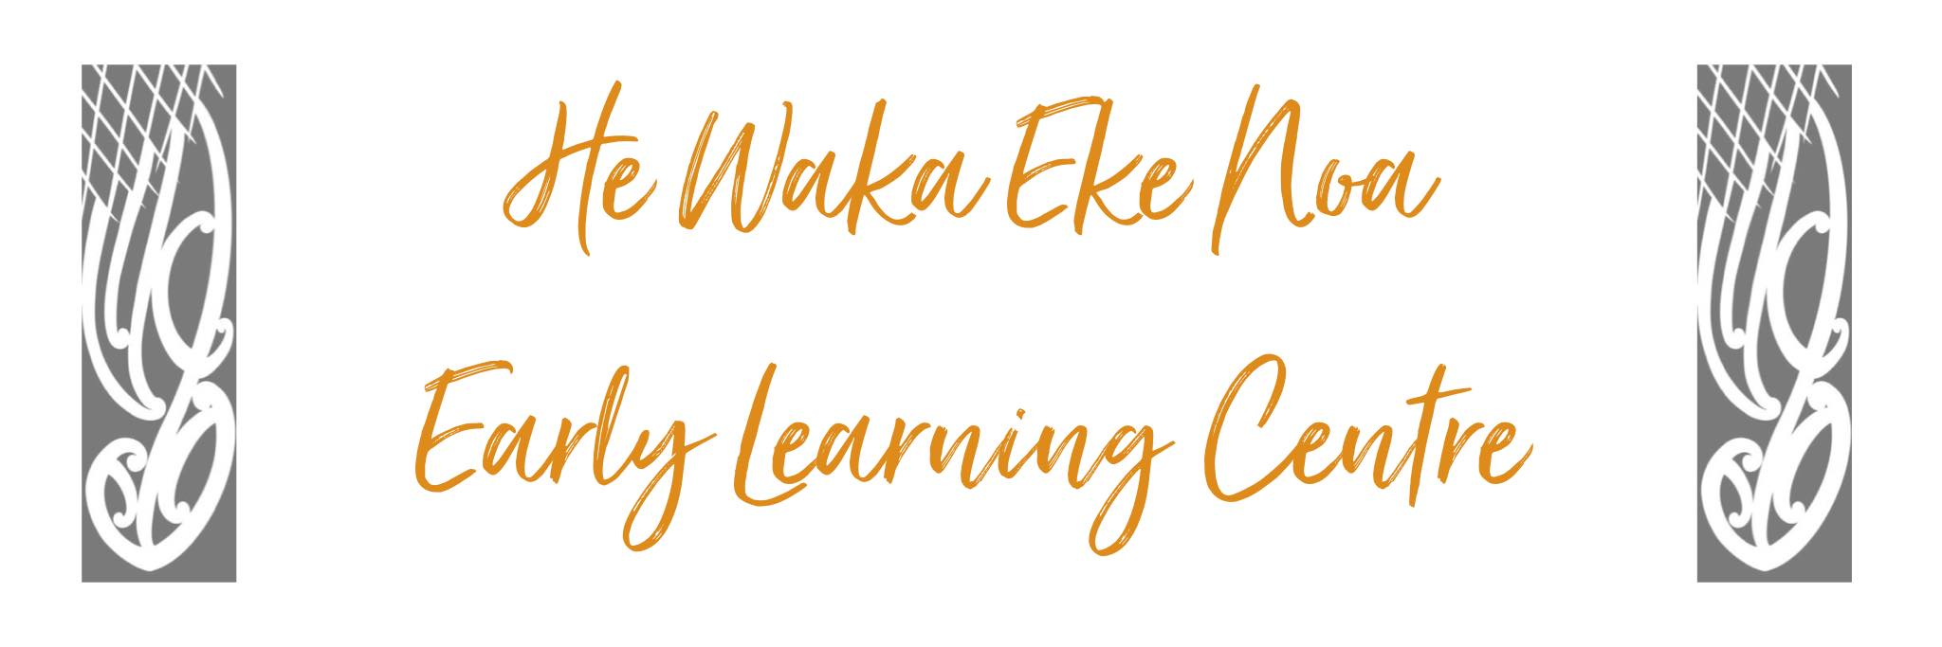

Food and Eating Policy

Procedure: Tamariki will be served nutritious, healthy food while they are present at the Centre in ways that support and promote their holistic development.

- Children are supervised and seated while eating.

- If a child has a specific food allergy, the centre Supervisor will be informed and staff advised. This information will be stated on the enrolment form.

- A list of all children and specific allergies will be kept on the inside door of the pantry and inside the front cover of the food safety record book. This list will be updated regularly and as required.

- If a parent requires their child to have a specific type of food i.e. low GI, gluten-free etc they will be asked to supply it.

- Children will wash their hands with soap and water and dry thoroughly before any meal times.

- Children will be encouraged to use the toilet (change nappy) and remove footwear before lunchtime meal.

- Children will wash their face and hands after each meal – Face clothes will be available near kai tables, in buckets, and accessible by children.

- An adult will sit at a table, with children, throughout the meal. The kitchen person and floating staff will support each table with anything extra that is needed. The adult responsible for their table will remain seated during the meal process to promote respectful, quiet conversation and an enjoyable, safe meal time. Children are to remain seated until the food is completely ingested and their mouths are empty.

- Whakapai kai will be said/ sung before each meal

Adults will encourage children to:
- take responsibility in asking for their choice of food
- to use manners to ask each other to pass things to each other
- to use cutlery appropriately
- to participate in mutual table conversation
- orderly table clearance and tidying up
- Adults will support younger children's skill and confidence levels by sitting close to them.
- Stay seated throughout the entire eating process
- All meals will be at a calm and relaxed tempo – children will set the pace for the length of the meal

- Under twos will be fed at times dictated by their personal needs.

- Pureed/mashed veggies will be offered to under two’s and other menu foods will be introduced as the child’s dietary needs change.

- Whenever possible under twos will choose which food they want to eat/try.

- Under twos will be fed at the baby room table if able to sit – on an adult lap if unable to sit.

- Nearly two-year-olds will be encouraged to partake in over two meal times to support the transition. Again, this will be dictated by the infant.

- Our older children will be positively encouraged to try the main meal at lunchtime to support an ever-increasing palate and dining experience.

- No child will have access to any fluid while in bed or (any other sleeping or resting area) Reg 26 (d)

- There is a plumbed in filter on the deck available for children to access at all times of the day. This will be serviced by the appropriate technician as service dates require or more should there be an issue. There is a water filter installed in the kitchen area for all staff to access.

- The daily menu will be posted on the kitchen menu boards for parents to view. A record of the menu is available for inspection for 3 months after food is served. This is a 7-day rotating menu that is changed each term.

- A food Safety Record Book is also available for inspection at any time.

- Should there be any alterations to the daily menu i.e. birthday parties, or matariki celebration these will be recorded and kept in the menu file.

- The menu file will also hold a copy of all ingredients/allergens used in specific menu items should parents/whanau be ask to inspect.

- The centre will keep a record of the weekly menu in the food safety record book and a flip folder located in the kitchen area for parents/whanau to access if desired. It is the responsibility of kitchen staff to ensure this menu is rotated appropriately (weekly)

- The centre Supervisor will ensure that staff, parents and officials on request can view the menu.

The following high–risk foods will not be served at the centre :
- whole nuts
- large seeds
- potato chips
- hard rice crackers
- dried fruit
- sausage or Cheerios
- popcorn
- any sweets or lollies.
- There will be a fully certified First Aider available at all times for every 25 children.
- We will use the attached guidelines for reference when altering high-risk food to lower its choking risk.

Date: | June 2024
Review Date: | June 2025
Consultation  Undertaken: | Staff/whanau/community

Links to:
Licensing Criteria HS 19 – HS23

