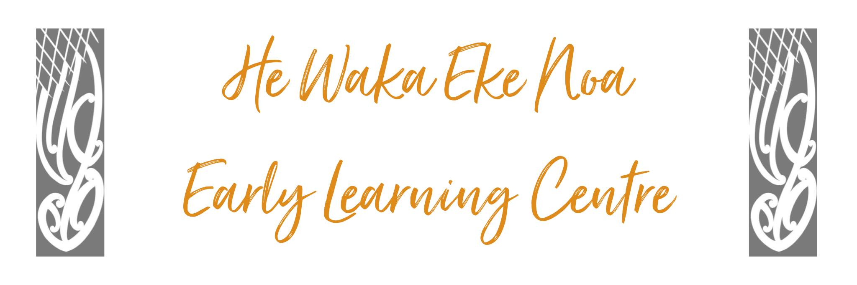
HEALTH & SAFETY FRAMEWORK POLICY
The purpose of this operational policy is to ensure Tamariki and adults are kept safe by meeting the health and safety requirements of the Ministry of Education’s Licensing Criteria for childcare centres; and relevant health and safety law requirements.

Position Statement
Our Centre provides a safe environment for children, staff, whanau and visitors. We achieve this by ensuring all practicable steps are taken to prevent accidents and incidents; but where these occur, by taking all practicable steps to understand why it occurred and to learn from this to prevent it from happening again.

Issue Outline

Both children and adults have accidents, even in safe environments. Children can also get sick quite suddenly or can be unwell on arrival at the centre. Our job is to maintain the well-being of our children by creating a safe and healthy environment and acting urgently and effectively to ensure health and well-being of all children.
Goals
This policy:
- shows the commitment of centre management and workers to health and safety
- aims to remove or reduce the risks to the health, safety and welfare of all workers, contractors and visitors, and anyone else who may be affected by our centre operations
- aims to ensure all work activities are done safely.
Responsibilities
Management is responsible for providing and maintaining:
- a safe working environment
- safe systems of work
- plant and substances in safe condition
- facilities for the welfare of all workers
- any information, instruction, training and supervision needed to make sure that all workers are safe from injury and risks to their health.

Workers are responsible for:
- ensuring their own personal health and safety, and that of others in the workplace
- complying with any reasonable directions (such as safe work procedures, and wearing personal protective equipment) given by management for health and safety

We expect visitors and contractors to:
- be familiar with the health and safety policies of our centre
- report any hazards, incidents or accidents they see to management.
General:
- All our management and staff share the responsibility for ensuring we offer a safe and healthy environment for all
- We have a first aid kit equipped to the standard set by the Ministry of Education and kept fully equipped
- We have an area where we can isolate sick children
- The centre complies with the current first aid training requirements as set out by the Ministry of Education.
Health and Safety Framework
The following framework outlines the range of centre health and safety policies required to comply under the Ministry of Education’s Early Childhood Education centre’s licensing criteria HS1 to HS33. It also includes Premises and Facilities licensing criteria PF3-PF31.
Centre Health & Safety Framework Policy
Prevention  (What we do to avoid something happening) | Response  (What we do when something happens)
HS2 Laundry Policy  HS3 Nappy Changing Policy  HS4 Fire and Emergency Evacuation Policy  HS7 Emergency Evacuation Plan  HS8 Emergency Drill Record  HS9 Sleep Monitoring Policy  HS12 Hazard and Risk Identification and Management System and Hazard Register  HS15 Carseat safety policy  HS17 Outings and Excursions Policy  HS18 Motor Vehicle Transport Policy  HS19 Food Policy  HS25 Accident and Illness Policy  HS26 Infectious Diseases Policy  HS28 Medicines Policy; Medicine Register  HS29 Medicine Administration Training Record  HS31 Child Protection Policy; Staff Safety Checking | HS25 & HS27: Incident, illness and Accident Record; Incident Investigation form  HS31 Child Protection Policy  HS7 – Emergency Evacuation Plan

Relevant Background (including legislation/regulation references)
Health and Safety in Employment Act
Health and Safety at Work Bill
Education (Early Childhood Services) Regulations 2008
Ministry of Education Licensing Criteria for Education and Care Services

Impacts of Policy on Staff, Parents, Children
Following this policy will ensure that the centre environment is safe; that parents and appropriate authorities are kept informed of accidents and illnesses where appropriate; and that appropriate records are kept to meet licensing and other legislative requirements.

Alignment with the Centre Philosophy
This policy ensures a framework is in place that supports a safe environment, a crucial part of creating and maintaining the well-being of children in our care and other adults.

Implications and/or Risks
Following this policy significantly enhances the opportunity for this centre to comply with legislative and licensing obligations, gaining trust with parents because of illness or accident prevention activities and management practices and maintaining public credibility.

Implementation
Relevant health and safety policies and practices are developed within this framework.

Review
Review annually or when there is a significant change in the area of the policy topic.
Date: | June 2024
Review Date: | June 2025
Consultation Undertaken: | Staff/Whanau/Management

