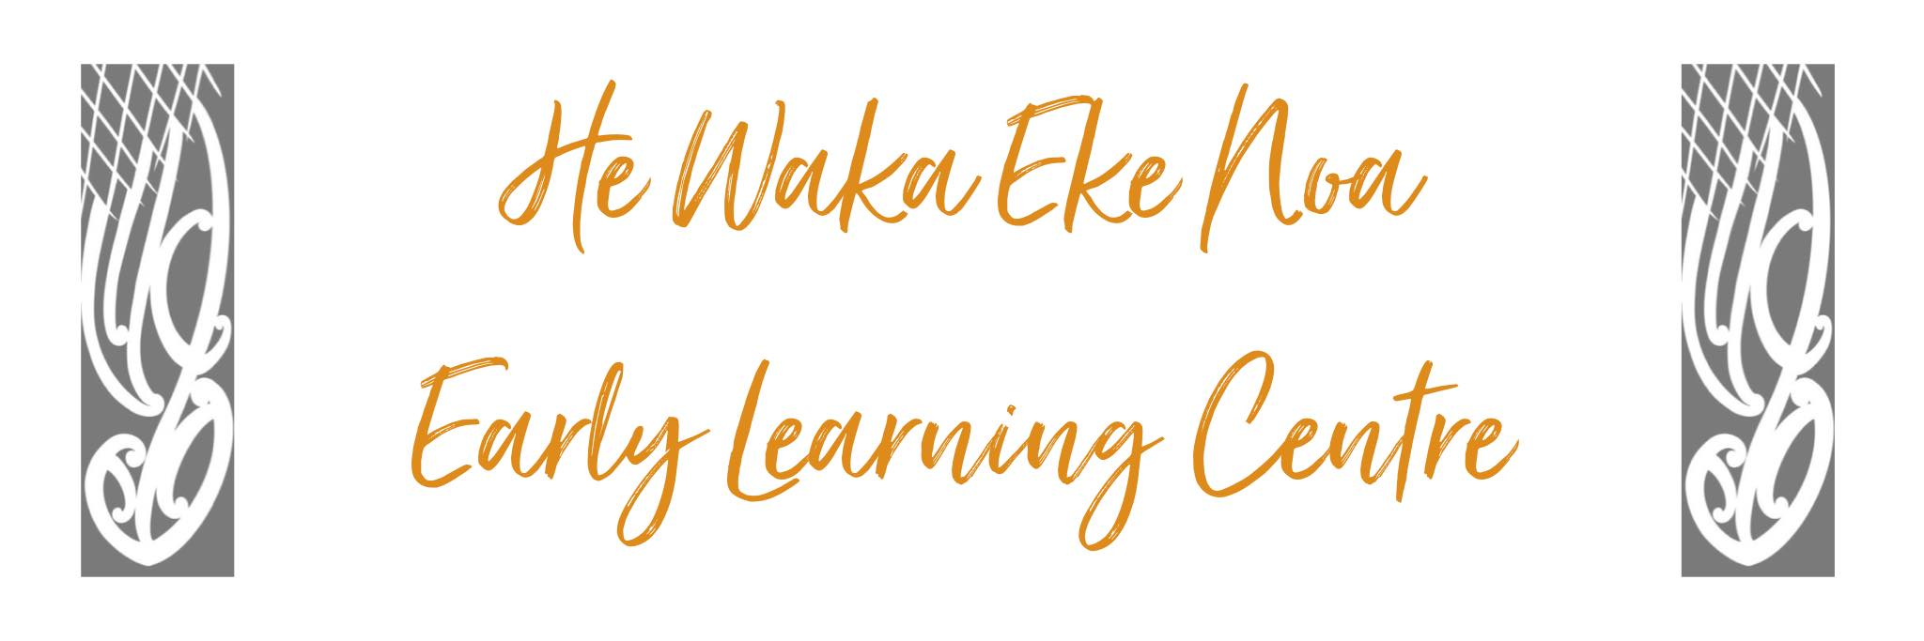
Incident and Injury Policy & Procedure

Purpose
- Tamariki will experience an environment where safety of all involved in centre life is paramount
- Appropriate action will be taken in case of an accident and parents/caregivers will be fully informed
- A minimum of one staff member to every 25 children will hold a current first aid certificate and will be present in the centre at all times.
- All practices and procedures will comply with the Health and Safety in Employment Act 2016

Procedure
- The first priority will be reassurance and support of the injured child or adult.

- ALL injuries, illnesses and incidents are recorded, even if only minor injuries are sustained. This is for two reasons:

- A very minor injury can sometimes become more serious after a period of time, e.g. a minor graze becomes infected and a child requires hospitalisation.

- A pattern or trend in the occurrence of minor injuries may lead to awareness of the need to make changes at the service.

- A record of all incidents, injuries, and illnesses that occur at the service will be kept in the Incident/injury/Illness register. Records will include the child’s name, date, time and description of the incident, actions taken, and by whom.

- The accident register will be signed by the person collecting the child – this requirement will be signaled by a parent note on the tablet used to sign in and out. Any injured adult will sign at the earliest possible moment after the incident/injury/illness.

- In the event of a head injury a call will be made or a message sent to the parent/caregiver to advise the child has had an injury/incident prior to them collecting the child at the end of the day. This call/message can be made out of courtesy more than concern.

- The incident, injury and illness register will be reviewed by staff regularly (2 monthly) or more if required at a staff meeting to discuss any areas of concern or any key triggers that have been identified or may need addressing. Patterns identified will be added to Hazards register for committee review.

- If the incident, injury, or illness is serious and requires hospital or medical attention the following steps must be taken:
- appropriate first aid is applied by first aider
- Second person calls ambulance - 111
- Second person calls the child’s parent /caregiver and gives details.
- The first aider will accompany the patient in an ambulance if parent/caregiver (of the child) has not yet arrived at the centre.

Hazard / Training Procedures

- Staff induction process will be used to ensure staff are aware of safety management procedures.
- Staff will be trained in the use of any equipment or chemical they are unfamiliar with handling.
- The Centre will identify, assess and control significant hazards.
- Staff will be asked to complete Hazard Identification forms should they identify any hazards. The form will be given to Supervisor and appropriate action shall be taken.
- Whenever a significant hazard is identified it will be isolated immediately, then either eliminated or minimised through education and information.
- All serious accidents (i.e. requiring ambulance services) will be reported to WORKSAFE 0800 030 040 Where there is a serious injury or illness or incident involving a child while at the service that is required to be notified to a “specified agency” the centre Manager will also notify the Ministry of Education at the same time.
- All contractors will be required to give assurances about their safety practices before they undertake any work contracted by He waka Eke Noa ELC

Authorised: | Management Committee
Date: | April 2024
Review Date: | April 2025
Consultation Undertaken: | Staff/whanau/management

Links to Licensing Criteria
HS 34, 12, 25, 27

