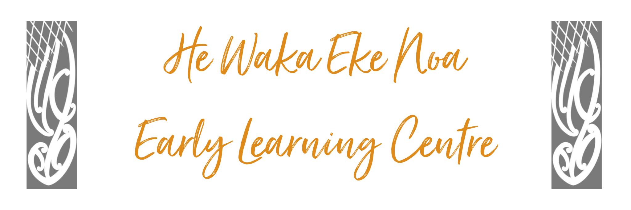
INFECTIOUS DISEASE POLICY

Policy:

To provide a safe and healthy environment at He Waka Eke Noa Early Learning centre by minimising the spread of infectious disease amongst the staff and children and staff.

Procedure:

- In compliance with the ECE Regulations 2008, All practicable steps are taken to ensure that children and staff do not come into contact with any person (adult or child) on the premises who is suffering from a disease or condition likely to be passed onto children and staff and likely to have a detrimental effect on them.

Centre Policy

- Children and staff with severe colds, coughs, diarrhoea, vomiting or infectious diseases listed on the 2nd schedule of the Health Regulations, 1996 must not be brought into the centre.
This is a necessary rule, not only to avoid the spread of infection to staff and children and staff but
also for the sake of the child.

- If your Child or staff suspected of having an infectious disease a medical certificate may be required before the Child or staff is allowed to return to the centre.

- If your Child or staff shows signs of an infectious disease over the weekend it is the parent or guardians’ responsibility to inform the centre as soon as possible.
- The centre has opted to keep its absence fees as low as is sustainable to allow whānau to follow this policy whilst minimising financial impact.
- Children and staff who become unwell while attending the service will be kept at a safe distance from other children and staff (to minimise the spread of infection) and the parent or other person authorised will be asked to collect the Child without delay.

Health Promotion
- In order to assist in infectious disease outbreaks the centre requests all immunisation records for children at the time of enrolment and keep these on file. HWEN respects whānau choice to vaccinate or not vaccinate tamariki however this information is required to help identify those at risk during potential or actual outbreaks.
- The centre from time to time shares health information for whānau via social media and Storypark. The centre will share information only from the Ministry of Health or the Ministry of Education to ensure all information is factual and the risk of spreading disinformation is minimised.

Managing potential disease outbreak
- Should there be an infectious disease outbreak the centre management committee will liaise with regional public health, Ministry of Health and Ministry of Education as required.
- All communications with whānau regarding an outbreak will be prompt, as advised by the above, with the aim of minimising transmission and maintain safety of tamariki and whānau

Date: | May 2024
Review Date: | May 2025
Consultation  Undertaken: | Staff/whanau/community

Links to: Licensing Criteria HS26, HS27

