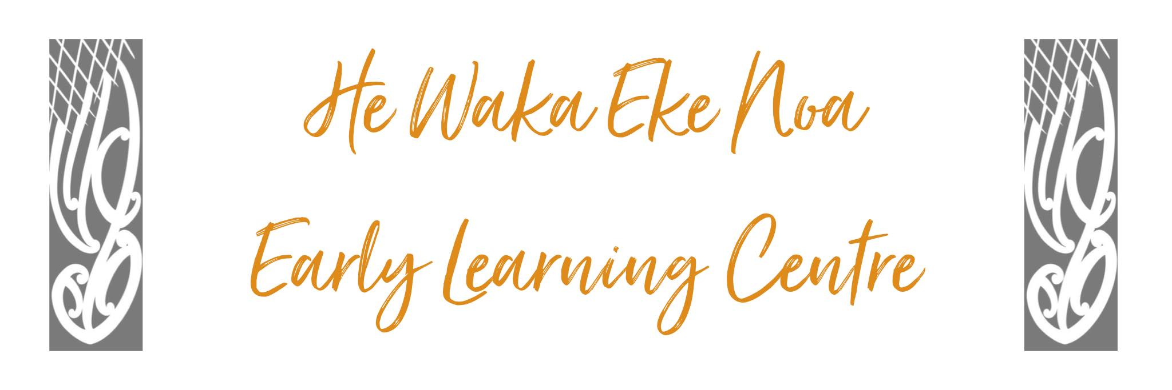
Māori as Tangata Whenua Policy

Policy:
We respect the unique position of Māori as Tangata Whenua in Aotearoa/New Zealand. We encourage an awareness and appreciation of the bi–cultural heritage of our country. We support Te Tiriti O Waitangi and the use of Te Reo Māori as a living language.

Te Whariki – Communication Goal 3. Children experience an environment where they experience the stories and symbols of their own and other cultures.

Procedure:

- Teachers are encouraged to use Te Reo Māori throughout their daily practice
- Teachers will discuss and inform others of appropriate practice with regard to tikanga Māori to increase awareness of the partnership inherent with the Te Tiriti O Waitangi
- Staff greet children, whanau, colleagues, and phone enquiries in both English and Te Reo
- Te Reo Māori me nga mahi a ringa is incorporated into all areas of the curriculum
- Professional development will be made available to assist teachers in extending their knowledge of both Te Reo Māori and local tikanga practices

Links to: Licensing Criteria C5, C6, C8, C12, C13

Date: | May 2023
Review Date: | May 2024
Consultation  Undertaken: | Staff/whanau/community

