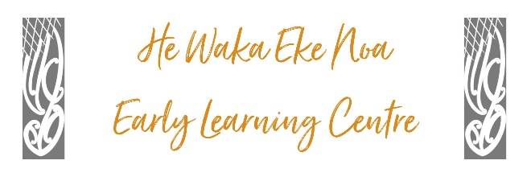

**No Cash Received Policy**

**Policy Statement:**

At He Waka Eke Noa Early Learning Centre, we prioritize the safety and security of our staff and families, as well as efficient financial management. To uphold these principles, we have implemented a "No Cash Received" policy, with the exception that cash will only be received during officially designated fundraisers. All electronic money transfers will be reflected in your statement sent weekly.

**Policy Scope:**

This policy applies to all employees, parents, guardians, and visitors to He Waka Eke Noa Early Learning Centre.

**Policy Details:**

Payment Methods: We encourage the use of secure and convenient electronic payment methods for all transactions, including, enrollment fees, and any other payments related to our services. Our preferred payment methods include bank transfers, credit/debit card payments, and electronic funds transfers.

**No Cash Handling**: He Waka Eke Noa Early Learning Centre staff members are prohibited from accepting cash payments on the premises, except during officially designated fundraisers.

**Fundraisers Exception:** Cash will only be received during fundraisers organized and approved by He Waka Eke Noa Early Learning Centre. During these events, designated staff members will be responsible for handling cash collections.

**Receipts and Statements:** All electronic money transfers will be reflected in the weekly statements sent to parents and guardians.

**Communication**: Parents, guardians, and visitors will be informed of this "No Cash Received" policy through various communication channels, including our website, enrolment documents, and during orientation. The inclusion of electronic money transfers in weekly statements will also be communicated as appropriate.

**Security Measures:** We are committed to ensuring the highest level of security for all financial transactions.

**Compliance:** Failure to comply with this policy may result in delays or inconveniences related to your child's enrolment and services provided by He Waka Eke Noa Early Learning Centre.

**Review and Updates:**

This "No Cash Received" policy will be reviewed periodically to ensure its effectiveness and relevance. Any necessary updates or amendments will be communicated to all stakeholders.

|  |  |
| --- | --- |
| **Date:** | **September 2023** |
| **Review Date:** | **September 2024** |
| **Consultation**  **Undertaken:** | **Staff/whanau/community** |