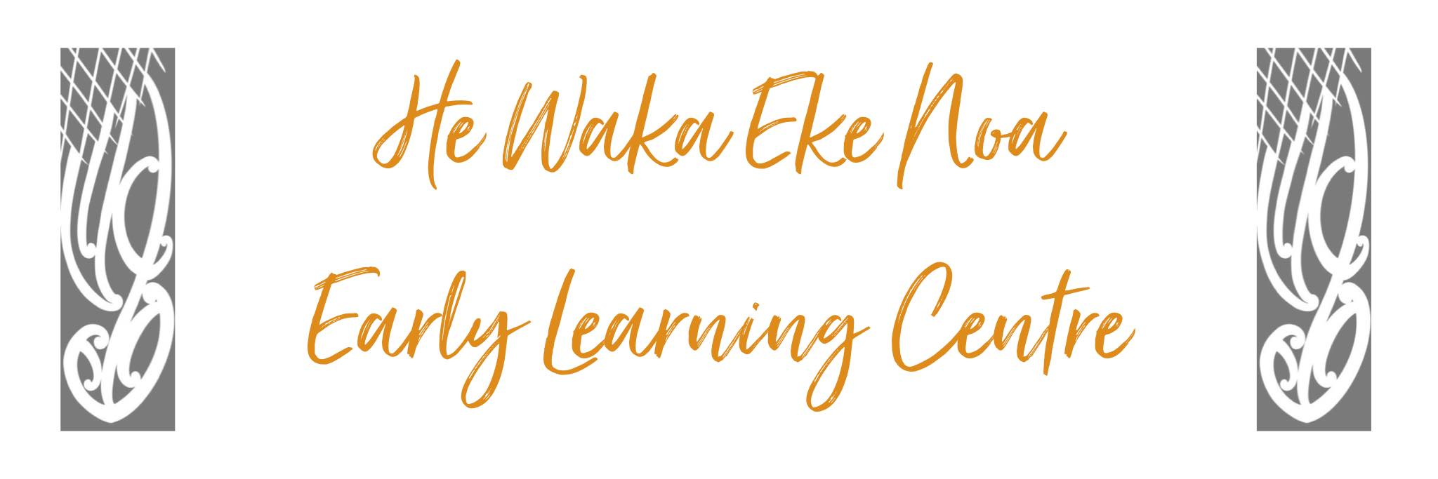
Privacy Policy

Policy: Any information gathered on any child or adult will only be used for legal and necessary purposes. Collection, storage and access will be governed by the requirements of the Privacy Act 2020 and amendments.

Procedures:

- Information will be collected directly from the individual or the individual’s legal guardian.

- The collection of information will be authorised by the individual or the individual’s legal guardian

- Information may be collected indirectly and disclosed for the prevention or detection of an offense only.

- Information will be kept in secure paper files and/or computer files. This information will not be disclosed to outside parties without consent by the person in question.

- Individuals will have the opportunity to access information collected about them and can ask for any errors contained within the information to be corrected.

- Information will be checked for accuracy before being used in any way.

- Permission to display children’s work and photos will be gathered on the enrolment forms.

- Information collected through unsuccessful job applicants will be destroyed

- The Supervisor will be the designated Privacy Officer.

- Information will be kept for no longer than it is legally necessary.

Date: | May 2024
Review Date: | May 2025
Consultation  Undertaken: | Staff/whanau/community

Links to: Regulation 47 Governance, management and administration standard:
Licensing Criteria GMA 7,10,11,12

