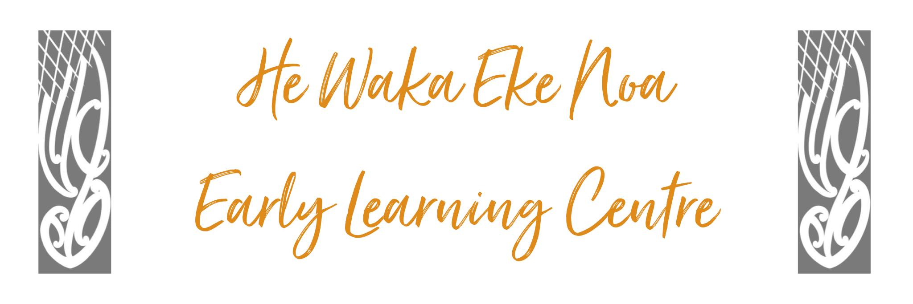

Student Placement Policy

Policy: He Waka Eke Noa is committed to supporting student placements by allowing the opportunity to practice current Early Childhood Education learning theories in a safe accepting environment.

Procedure: He Waka Eke Noa will accept students on placement upon the following grounds:

- Confirmation from the training provider that the student placement has undertaken the appropriate vetting processes including a current police check.

- An appropriate Associate Teacher is available to undertake student evaluation and assessment expectations.

- Student placements undergo the following induction procedure.

Induction Procedure: The student will participate in the induction process that includes:

- Initial meeting with Associate and staff members prior to commencement of their practicum.
- Reading and agreeing to adhere to all centre policies, procedures philosophy, and relevant legislation.
- Signed and dated student agreement/contract.
(normally provided by the student). This agreement should include
Start/finish times, appropriate clothing/footwear, amount of daily
hours required etc

Centre Expectations:
- All staff are expected to support and guide students while on practicum.
- No student will change or toilet a child/infant while on practicum
- The Associate Teacher will be granted time off the floor to partake in the triadic discussion and any other with visiting lecturer during the student’s practicum.

Discipline and dismissal procedures:
- If a staff member has any concerns regarding the students’ conduct while on practicum they are to approach the Associate Teacher and Supervisor immediately and discuss concerns and find resolutions.
- Should at any time throughout the practicum the student’s contract not be upheld the Associate Teacher will discuss the incident with the student. If no appropriate resolution can be found the Associate Teacher will organise a triadic meeting with the lecturer and student to assist with resolutions. If still no satisfaction the Associate will enlist support from the Centre Supervisor and lecturer to remove the student from the centre.
- All the above procedures will be documented by way of incident forms and complaints procedures. The student will be included throughout the entire process and have the right of reply.

Serious Misconduct procedure:

Serious Misconduct is constituted by:
- Student placements attending employment at the centre under the influence of drugs or alcohol.
- Deliberately vandalizing centre equipment or property.
- Ill-treatment of children/tamariki

It will be the responsibility of the Manager/Supervisor to advise the student of the allegation and ask for an explanation that will be documented by the Manager/Supervisor. The training provider will be contacted immediately and advised of the serious misconduct and that the student placement has been dismissed.

Date: | October 2023
Review Date: | October 2024
Consultation  Undertaken: | Staff/whanau/community

Links to: Licensing Criteria: C3, C4

