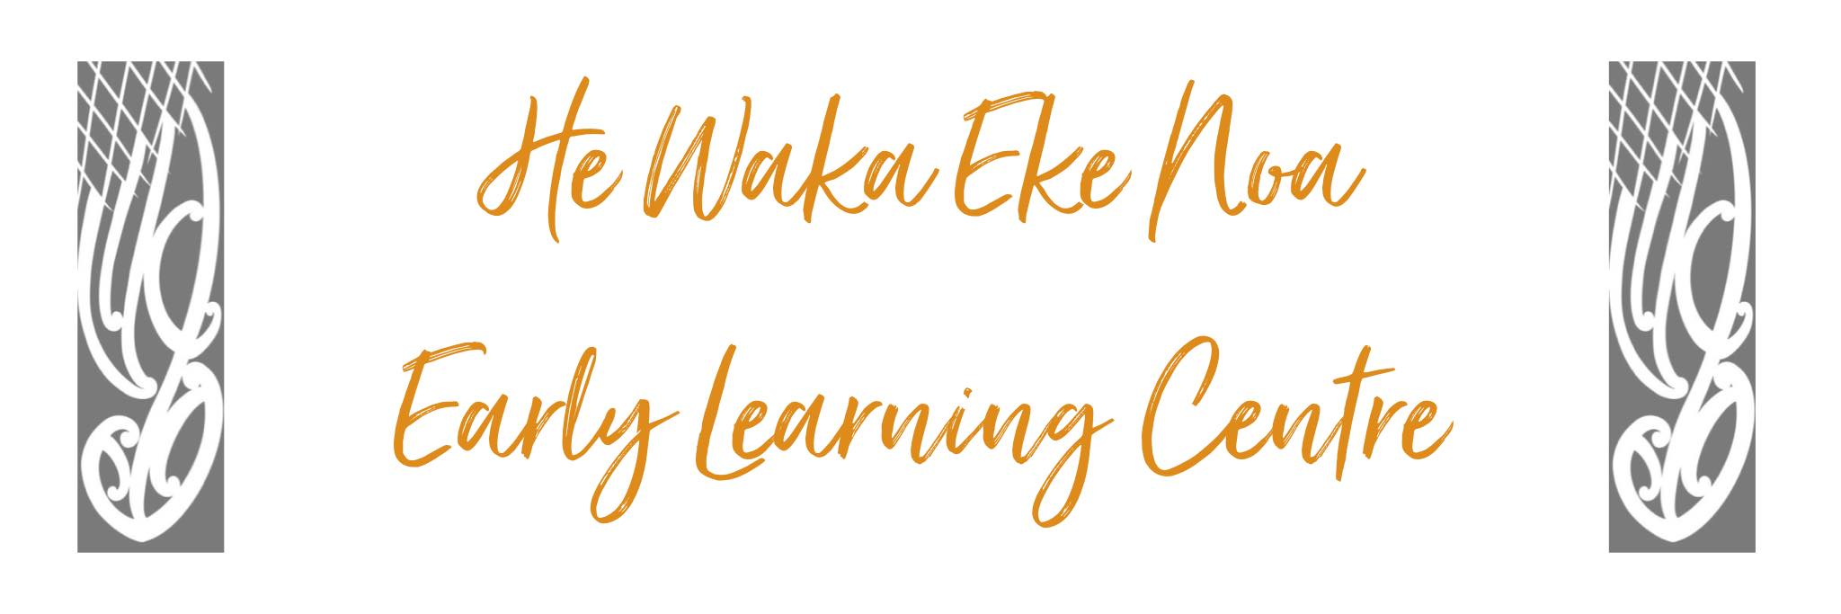

TOILETING/NAPPY CHANGING POLICY

Position Statement – Tamariki will
We will provide a safe, healthy and hygienic environment in which staff treat children with dignity and respect at all times. We will work with parents/Whānau to support and continue their child’s toilet training once it has been successfully established in their home environment. To maintain a safe and hygienic environment for everyone in the Centre we must balance the wishes of the parents/Whānau with the health and safety standards of the Centre. The initiation of toilet training should always be based on the child's developmental level rather than on the child's age. Initiating toilet training before the child is developmentally ready can create stress and anxiety for the child and the family, and increase the length of time it takes to train the child.

Issue Outline
Clear policies, procedures and communication with parents will help to avoid situations where parents begin toilet training before a child is developmentally or emotionally ready for a number of different reasons, such as financial. This can result in distress for the child, lowering of their self-esteem, make the process take longer or in physiological problems caused by the child holding on. Regular and repeated toileting accidents around the Centre can lead to an unhygienic environment with a risk of infection.

Detail
Procedure:
To promote the health and wellbeing of children and staff
To ensure that nappy changing and toileting are done in a relaxed
positive atmosphere and the child is treated with respect and dignity at all times
- Toileting and nappy changing will occur every 2 hours or sooner if required
(respect children’s right to say no, following through with a reminder that toileting
will need to happen after 5mins).

- Record each change on the appropriate toileting chart.

- Disinfect changing mat/s after every nappy change.

- Support colleagues, as children’s needs dictate, throughout the day. Be prepared to offer help where needed.

- Nappy changes and toileting are perfect times to strengthen personal relationships with tamariki. A child’s mana and dignity will be paramount at all times.

- Check bathroom throughout the day. Sweep, SPOT clean and disinfect as required ensuring a high standard of hygiene throughout the bathroom facilities.

- Scrub and disinfect hair brushes as required throughout the day.

- Scrub and disinfect bath/stools/rubbish & nappy bins daily before the end of your shift; or as required.

- Rubbish containing nappies or bodily fluids is NOT to be transported through the kitchen area. These items will need to be placed in the wash house via the outside pathway and through back entrance.

- Restock toilet paper, hand towels, wipes, gloves, tissues, nappies, plastic bags and spray n wipe (3 pumps per 500 mls) throughout the day as required. Restock at the end of the day.

- If any of these supplies need to be ordered from supplier please complete the appropriate form located in the kitchen folder. These will be ordered weekly.

Alignment with Other Policies
This policy aligns with:
- Laundry Policy
- Health and Safety Policy.

Impacts of Policy on Staff, Parents, Children
This policy aims to avoid situations where parents begin their child’s toilet training before they are developmentally or emotionally ready, which can be very distressing for the child and create further problems for the child, family and Centre.

Implications and/or Risks
Following this policy can help to minimize the risk of spread of infection. Having a clear policy and communication with parents will significantly reduce the risk of unrealistic expectations that may occur.

Implementation
Clear procedures have been developed and are discussed and amended as required.

Review
Review annually or when there is a significant change in the area of the policy topic.
Date: | June 2024
Review Date: | June 2025
Consultation Undertaken: | Staff/Whanau/Management Committee

