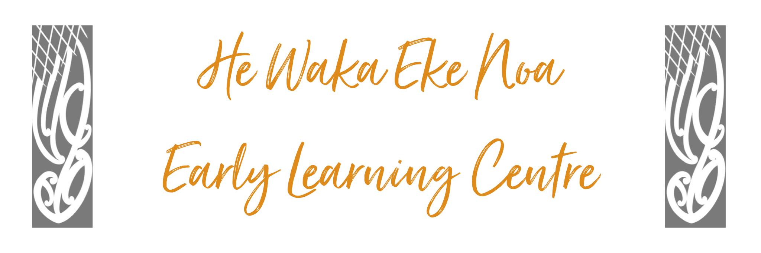

TOILETING FACILITIES POLICY
Thte purpose of this operational policy is to ensure the safe provision of facilities for children and adults by meeting the licensing criteria PF25 and PF26.

Position Statement – Tamariki will
Our centre provides nappy changing facilities that are safe, fundtional and hygenic for the children and adults at the centre. As an employer we have a primary duty of care to provide a work environment and have practices in place that reduce risk to health and safety under the Health and Safety at Work Act 2015.

Issue Outline
To ensure the nappy changing facilities are safe, hygenic and appropriate for both the child(ren) being changed and the adults who are changing them (Health and Safety at Work Act 2015), minimising risk to both.
We aim to uphold the health and well-being of the children by ensuring that there are suitable facilities and practices for washing children who vomit or soil themselves, reducing the risk of cross infection.

Detail
- The nappy changing facility is of a suitable height and construction to ensure safety and hygiene
- Facilities are kept free from hazards, maintained and in good repair
- Procedures are in place to keep the area clean
- The facility includes suitable storage
- The nappy changing area promotes independence, provides some privacy but can be seen from another area of the service
- The facility is next to a handwashing area and provides washing for soiled children comfortably
- The area is away from food preparation
- Children are able to safely climb onto the changing facility independently, reducing risk to adults lifting heavy children
- There is a shub/washdown facility in each bathroom.
Alignment with Other Policies
This policy aligns with:
- Nappy changing policy
- Health and Safety employment

Relevant Background (Including Legislation/Regulation/Licensing References)
Licensing criteria 2008, child health and well-being:
PF25: There are safe and stable nappy changing facilities that can be kept hygienically clean. These facilities are located in a designated area near to handwashing facilities, and are adequately separated from areas of the service used for play or food preparation to prevent the spread of infection. The design, construction, and location of the facilities ensure that:
- they are safe and appropriate for the age/weight and number of children needing to use them;
- children's independence can be fostered as appropriate;
- children's dignity and right to privacy is respected; and
- some visibility from another area of the service is possible.
PF26: There are suitable facilities provided for washing sick or soiled children and a procedure outlining how hygiene and infection control outcomes will be met when washing sick and soiled children.
- There is a procedure outlining how the service will ensure hygiene and infection control outcomes are met when washing sick and soiled children (related to clause 45(1)(a)(ii) of standard)
- Health and Safety at Work Act 2015

Impacts of Policy on Staff, Parents & Whanau and Children
This policy aims to ensure the childs safety, independence and diginity while using the facilities and prevent spread of infection. The policy minimizes the risk of staff injury due to lifting heavy children.

Alignment with the centre philosophy
This policy ensures a safe mana enhancing environment in line with our philosophy.

Implications and/or risks
Following this policy significantly reduces the risk of failing to meet the legal requirements under the licensing criteria 2022. The employer has a primary dty of care to provide a work environment and practices in place that reuce risk to health and safety under the health and safety work act 2015.
Implementation:
Clear procedures have been developed and staff trained to follow them.
Review:
This policy will be reviewed annually or when there is a significant change in the policy topic area.
Date: | June 2023
Review Date: | June 2024
Consultation Undertaken: | Staff/Whanau/Management Committee

