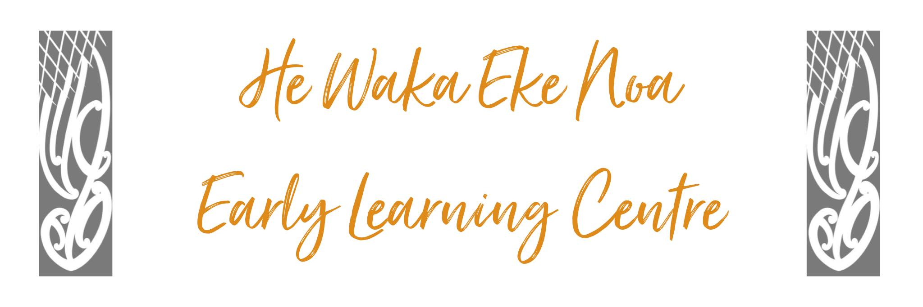

TRANSITION POLICY

POLICY:
Tamariki will be empowered to successfully negotiate transitions within and beyond the Centre through procedures that acknowledge the continuity of learning and overall well-being and sense of belonging for the child.

PROCEDURE:

- In partnership with staff with whanau, all staff will positively support children and their families through times of transition either within our c entre or beyond i.e. a different early childhood setting or school.

- There will be a leaving ceremony for each child during their final days. This will include an invite to whanau to celebrate their forthcoming transition. We will adorn the child with our centre korowai reflecting their whanau aspirations. Photos will be taken and displayed on our celebration wall.

- Whanau and children will be encouraged to continue links with the centre.

TRANSITIONING FROM UNDER 2 TO OVER 2 AREA:

- 2 – 3 weeks prior to a child’s 2nd birthday the following steps will begin to ensure that they will be empowered to successfully negotiate this transition within the Centre through procedures that acknowledge continuity of learning and overall well-being and sense of belonging for the child.

- The child will be given frequent opportunities to partake in the over 2’s routines such as mat times and meal times with the support of an under 2 teacher.
- A whāriki/placemat will be made with each child.

- The child will be encouraged and supported to take increasing responsibility encouraging independence. This may include hand & face washing, placing bag in locker, putting clothing into bag etc.

- At kai times, the child will be assisted and supported to develop skills such as choosing own spreads, spreading on toast, cutting their own fruit, and feeding themselves using cutlery and pouring their own drink. At the end of our meal they will clear their plates & cup and place these on the bench, wipe whāriki/placemat and put away chair before they leave to play.

- Teachers responsible for toileting the over 2’s will invite the child to have their toileting needs met by them.

- As the child celebrates their 2nd birthday their portfolio will be transferred to the over 2’s area for the teachers to familiarise themselves with, and their bag placed in outside lockers.
- The procedure of transition will remain fluid with the teachers being led by the child as their sense of belonging, security of new relationships and familiarity with routines is evidenced by their settled and responsive reciprocal behaviours in the over 2 learning environmen

TRANSITIONING TO A DIFFERENT EARLY LEARNING ENVIRONMENT:
Staff will prepare a mini portfolio which captures the essence of the child’s learning journey at Forum North Childcare & Education Centre for the child’s whanau to share with the new setting and teachers.
This will include an invite to view further information with parental consent via Storypark.

TRANSITION TO SCHOOL PROCEDURE:
Several months prior to a child’s 5th birthday the following steps will begin to ensure that they will be empowered to successfully negotiate their transition to school through procedures that acknowledge continuity of learning and the overall well-being and sense of belonging for the child.

- A school information booklet will be formulated of each of the local schools which will include relevant information and photo’s of areas of the school including the toilets, playground, classroom, key teachers etc.
- Approximately 8 weeks before the child is due to start school a designated teacher will initiate a conversation with the parents of the child to establish which school it is likely their child will be attending. Our transition policy and support offered by our team will be clearly outlined to the child’s parents/whanau.
- A designated teacher will contact the school and request a brief meeting to introduce ourselves and familiarise ourselves with the new entrant class and the teacher’s expectations and protocols relevant to the child starting school. This meeting is to establish a reciprocal relationship with the new entrant teachers of our local schools as we outline our transition policy and invite them to visit us and the child during their time at the Centre.
- Establish whether there is an opportunity to organise a school visit with the child which will support the parent-child visit schedule.
- Teachers will work alongside the child, whanau and parents to support the learning of the relevant kaupapa of the school – with the use of the school information pack.
- A transition to school portfolio will be prepared before the first school visit as a taonga of information about the child for them to share with their new teacher and classmates.
This will include information about Storypark link.

The link for a positive transition from our early learning environment to school is “whakawhanaungatanga” We also acknowledge that whakapapa is a connection to people through genealogy.

Children’s continuity of learning connects with their experiences, knowledge, skills and attributes. In an assessment, framework whakapapa is where past learning connects to learning in the present, which continues to grow and evolve into the future.
Whanau and teacher relationships within the early learning environment and our school communities are paramount throughout this transition period.

Authorised: | Management Committee
Date: | March 2023
Review Date: | March 2024
Consultation Undertaken: | Staff/whanau/Management

