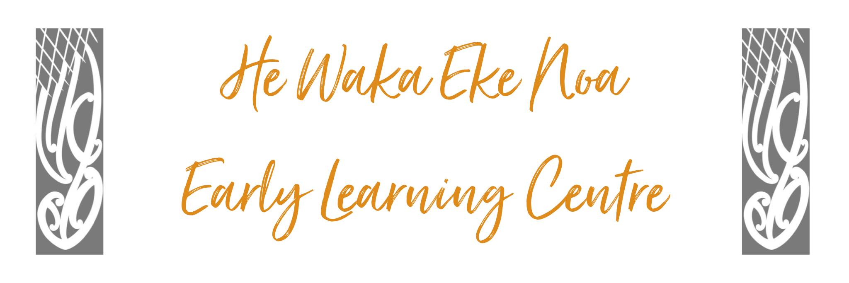

PHILOSOPHY

He Waka Eke Noa is a whanau-orientated community-based early learning centre. We embrace Whanaungatanga as one of our core values where interconnected, reciprocal and responsive relationships are celebrated.

We acknowledge each child reflects inherent dispositions of who they are and where they come from.
We acknowledge “Taonga tuku iho” attributes inherited from their tupuna and through our values whanaungatanga, manaakitanga, kotahitanga, kaitiakitanga and rangatiratanga, we aspire to uplift and nurture each tamaiti.

Upholding mana throughout our approach to teaching and learning ensures tamariki are affirmed and respected. Our vibrant team of Kaiako are guided by the principles of Te Whāriki, we recognise tamariki as creative partners, authentic learners and capable problem solvers in a shared learning journey. We are committed to working alongside tangata whenua and tangata tiriti to celebrate and uphold the aspirations contained within Te Tiriti o Waitangi.

Our practice reflects Aroha mai, Aroha atu—the reciprocal give and take of life. Our well-being and the well-being of te taiao (the natural environment) are deeply interconnected, and as a learning community, we strive to be kaitiaki (nurturers and guardians) of this connection, an as a team we continue to create a beautiful, inspiring space to celebrate, grow, support and empower one another.

He waka eke noa

A canoe which we are all in
with no exception

