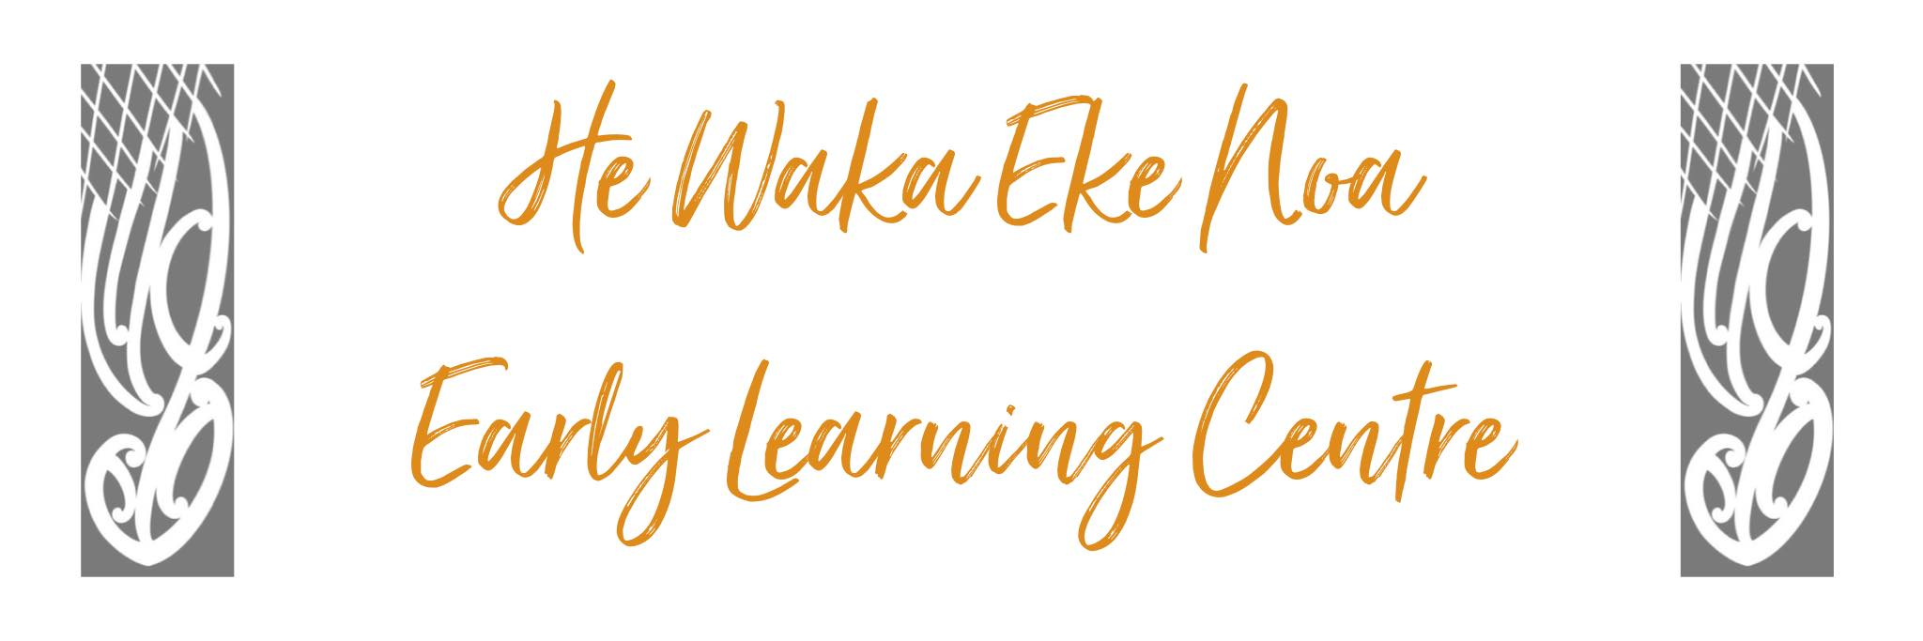

Complaints Policy

He Waka Eke Noa Early Learning centre affirms our community’s right to make any concern known to management and staff. We are interested in listening to and considering other views. There are many ways that you can provide feedback to us. Via email, storypark, messenger and through conversations with the team. We will investigate any specific issue with the view to improving the future performance of the organisation.

Procedure

Any complaint about non-compliance with licence conditions, management or staff must be:

- WRITTEN

- SIGNED

- DATED

It should be as specific as possible.

It should be addressed to the Chairperson or Secretary of the Management Committee and posted to:
60 Riverside Drive
Whangarei

If you feel your complaint has been unresolved, you can contact the Ministry of Education directly.
Whangarei District Office
24 Kaka Street, Morningside

PO Box
911 Whangarei
0140

Phone 09 4368900
enquiries.whangarei@minedu.govt.nz
Copies of the Early Childhood Regulations (2008) and the latest Education Review office reports are available. The Education Review Office publications and reports are also available at ero.govt.nz.

HE WAKA EKE NOA
EARLY LEARNING CENTRE

Procedure for raising complaints or concerns

Any complaints about non-compliance conditions, Management or staff concerns must follow the below procedure:

WRITTEN


SIGNED

DATED

Address to Chairperson or Secretary of the Management Committee
60 Riverside Drive
Whangarei

If you feel your complaint has not been resolved you may escalate your concern to

Whangarei District Office
24 Kaka Street, Morningside
PO Box 911
Whangarei
0140

Phone 09 4368900
enquiries.whangarei@minedu.govt.nz
Authorised: | Management Committee
Date: | August 2024
Review Date: | August 2025
Consultation Undertaken: | Staff/Whanau/Management

