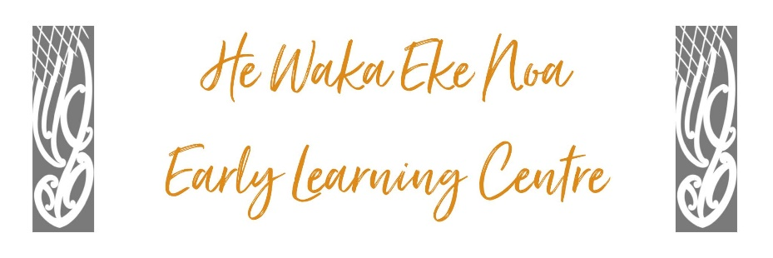

**INAPPROPRIATE MATERIAL POLICY**

**PURPOSE:** The safety and well-being of the child is our top priority. We support families/whānau to protect their children and we provide a safe environment, free from physical, emotional, verbal or sexual abuse.

We uphold the safety and well-being of children by ensuring that pornographic or violent material (electronic games, DVDs, websites, magazines, etc) are not available to children.

**PROCEDURE:**

* All practicable steps are taken to protect children from exposure to inappropriate material (for example, of an explicitly sexual or violent nature)
* Any questionable material will be removed from magazines or publications prior to the children using them

* Any use of centre devices by children throughout the day will be monitored by adults.
* Access to the centre’s computer network, computers, and Internet access facilities, requires a password-protected personal user account.
* HWEN will take all reasonable steps to filter or screen all material accessed using the centre’s network or Internet access facilities by utilising the above procedures. However, when using a global information system such as the Internet, it may not always be possible for the centre to restrict access to all such material. This may include material which is inappropriate in the centre learning environment, dangerous, or objectionable as defined in the Films, Videos and Publications Classification Act 1993.

|  |  |
| --- | --- |
| **Authorised:** | Management Committee |
| **Date:** | May 2024 |
| **Review Date:** | May 2025 |
| **Consultation Undertaken:** | Staff/whanau/management |

Links to HS32