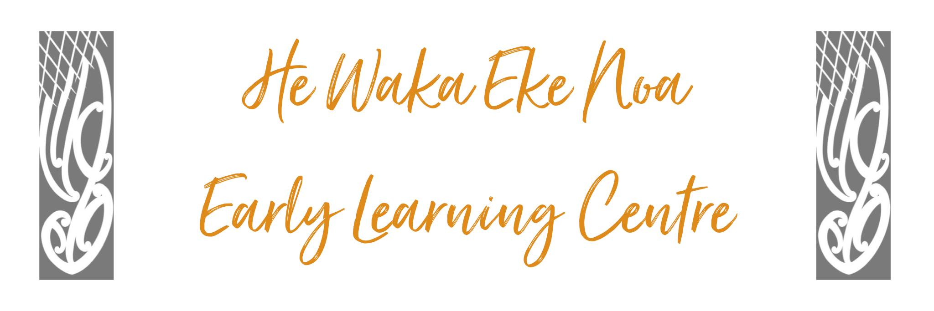

LAUNDRY POLICY
The purpose of this operational policy is to ensure there is an appropriate response for the hygienic laundering (off-site or on-site) of linen used by children and adults in order to meet Licensing Criteria HS2.

Position Statement
Our centre maintains a high level of hygiene by weekly cleaning of items used by the children including dress-up clothing.

Issue Outline
Regular cleaning of towels, tea towels, cloths dress up clothes, bedding and other such items used by children is essential to control the spread of infections.

Detail
General:
This policy outlines the practice followed in ensuring that linen used by children at the centre is hygienically laundered. This involves:
- Using a washing machine at the centre and/or sending off-site to a commercial Laundromat (or other facility)
- A list of linen and other items that need regular cleaning is displayed on a whiteboard on the wall.
- It is part of the Kitchen persons role to ensure these items are laundered daily/weekly or as required.
- Our centre does its own washing however we use a commercial cleaner once a term (or as required) to launder items that are too large for the washing machine.
- All kitchen laundry is to be soaked separately in WHITE buckets provided below the whiteboard and washed separately from other daily items.
- All soiled items are to be soaked in RED buckets provided and laundered separately to all other items.
- A whiteboard in the laundry records is used to record all soaking times to ensure they are well disinfected.
- Separate washing baskets are provided to separate bedding, general washing and clean washing.
- All staff are made aware of the procedures during orientation.

Alignment with Other Policies
- HS12 – Hazard identification
- HS30 – Children are washed if they are soiled.

Impacts of Policy on Staff, Parents, Children
A standardised system keeps children safe by ensuring that cleaning is done on time and to appropriate standards. This gives assurance to staff and parents that the materials children use are hygienic.

Implications and/or Risks if not followed:
- Children and/or adults at the centre are put at risk of infection and/or contamination from soiled or improperly laundered linen
- Irregular practice of timing and quality of laundry.

Implementation
Clear procedures have been developed and staff trained to follow them.

Review
Review annually or when there is a significant change in the area of the policy topic.
Date: | May 2024
Review Date: | May 2025
Consultation Undertaken: | Staff/Whanau/Management Committee

