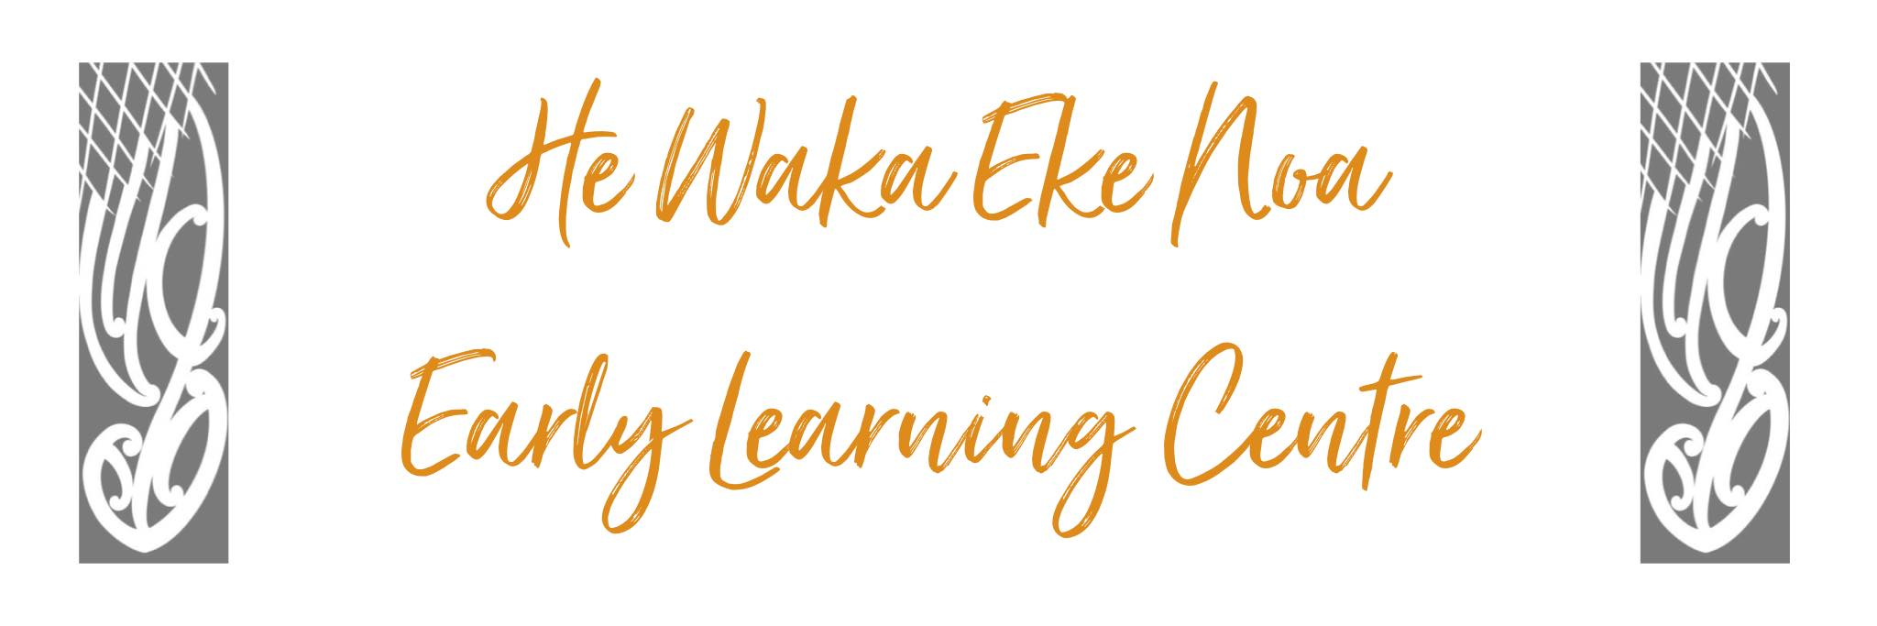
Organisation Policy

POLICY:

The provision of an efficient management structure and organisation policy will show clear lines of communication, responsibilities and processes for consultation.

PROCEDURE:

- The Management committee elected by parents and stakeholders will administer the centre.
- The Management Committee is comprised of the elected positions. Those being:
Chairperson
Secretary
Staff liaison officer
EEO coordinator
Treasurer
- The sub-committees operating in the coming year will be:

  - Staffing
  - Other sub-committees may be formed as required

- The responsibility for the day-to-day management of the centre is placed in the hands of the Supervisor in accordance with the job description.
- Management committee meetings are open, and generally held at 5:30 pm at the centre, once a month.
- The centre will be administered according to our policies, early childhood regulations 2008, and our constitution dated October 1991 and its amendments.
- He Waka Eke Noa Early Learning Centre Inc is a duly incorporated society and charitable trust.

Date: | May 2024
Review Date: | May 2025
Consultation  Undertaken: | Staff/whanau/community

Links to:
Licensing Criteria GMA2

