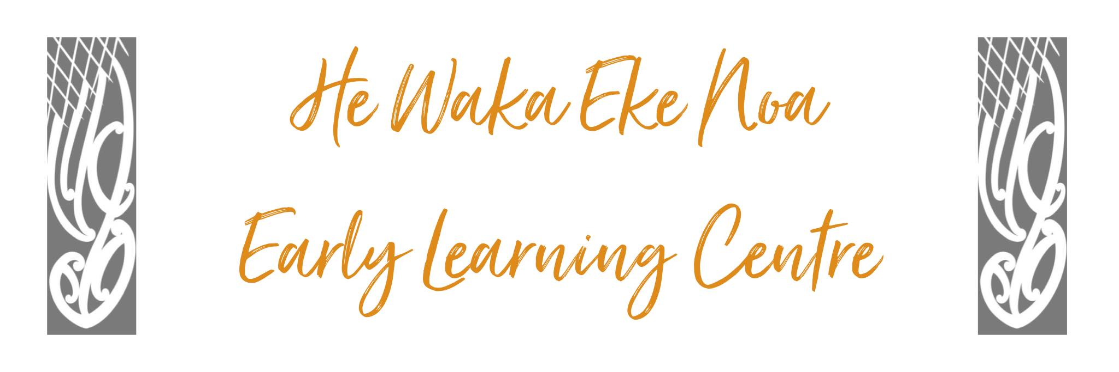
PHILOSOPHY REVIEW POLICY

Policy:

To develop and regularly review the Philosophy Statement and will include parents, whanau and staff in the consultation process.

To ensure variable aspects of the statement of philosophies are reconsidered for appropriateness in the light of any significant circumstances that may have changed in the interim period.

Procedure:

- The Management Committee and Staff will once a year (more if required) will write up in their management plan to formally consider the statements that are part of the Centre’s Statement of Philosophy, annual plan and after reflection on matters (such as changes to statutory obligations, governing authorities, resources, service intentions, etc) decide whether there are reasonable grounds to change any part of those statements.

- Management will consult with staff, parents and whanau that the statements are being reviewed, indicate any intention to confirm or change (indicate the nature and reasons for any change, if any); and to offer a means (by way of meetings, letters, information on the notice boards etc) by which they can provide ideas and feedback.

- Management and the Management Committee of the centre will consider any ideas and feedback and decide on whether any changes to these statements should be made.

- The process and decision should be recorded (in meeting minutes or notes) and the decision will be communicated to staff, parents and whanau by notice or newsletter.

- Any changes to the Centre’s Statement of Philosophy need not be submitted to the Ministry of Education.

Links to Licensing Criteria GMA 4,5,6

Date: | Feb 2024
Review Date: | Feb 2025
Consultation  Undertaken: | Staff/whanau/community

