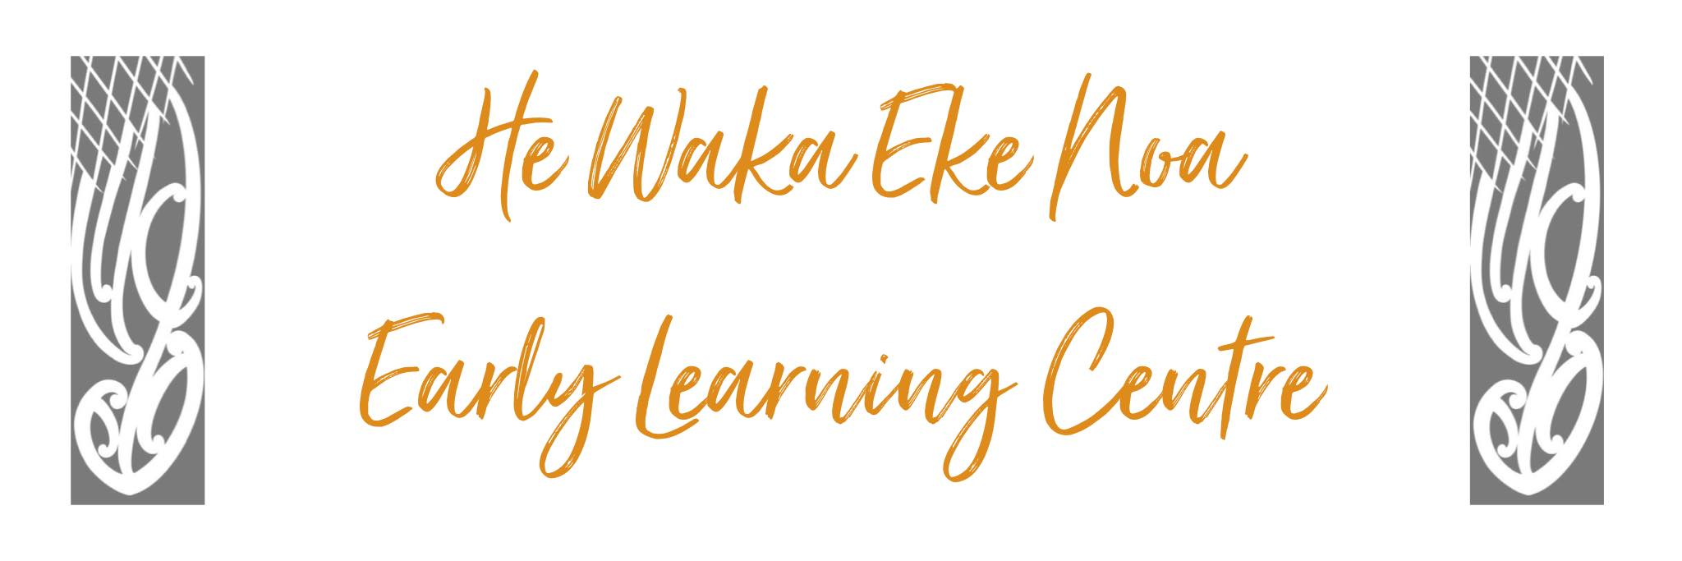
Settling Children Policy

Policy: There will be a ‘settling period’ for each new child and any child that has been away for long periods. The child will be accompanied by their parent/caregiver until the child demonstrates that they feel emotionally safe and secure in the Centre environment.

Procedures:

- The child will make a minimum of three visits to the Centre with the
Parent/caregiver or whanau members.

- Settling time will be used to let the child become familiar with routines, other children, staff and practical issues around toileting, eating and resting. It will also give time for the parent/caregiver to start the whakawhanaungatanga process and begin to develop a relationship with staff.

- A child will not be left at the Centre without their parent/caregiver/whanau until staff are confident that the child will be able to competently manage to participate in the programme with the support of staff. This includes eating drinking and overall well-being.

- One staff member working with the child’s age group will spend time with the child and caregiver getting to know them.

- Parents/ Caregivers/whanau will be asked to fill in individual aspiration forms about their child and this will be discussed with staff during the visits. This will enable staff to relate to the child about matters the child knows.

- Children will be supported to bond with a staff member. The initial bonding will be respected until the child feels secure and safe to extend and expand relationships with other staff members.

Date: | September 2024
Review Date: | September 2025
Consultation  Undertaken: | Staff/whanau/community

Links to
Licensing Criteria C3, C4, C6, C11, C12

