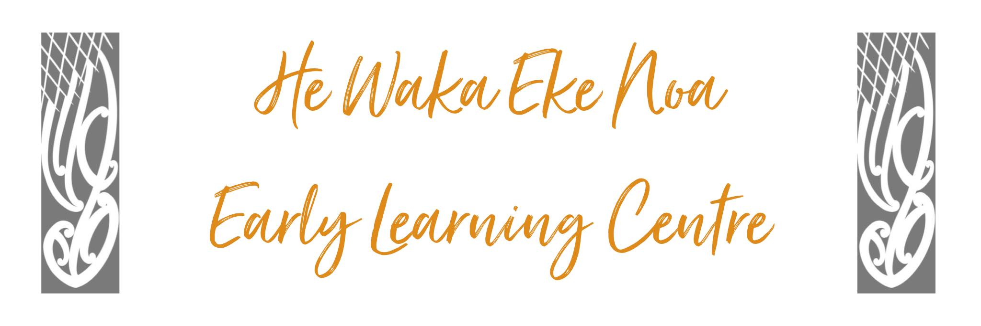

SOCIAL COMPETENCE & POSITIVE GUIDENCE POLICY

Policy:

We believe that all children have individual needs, which, through a process of discussion with caregivers/whanau and staff observations, should be recognised and, as far as possible, met. We believe a child’s right to have their social competence nurtured and developed is integral. Staff are expected to build respectful relationships with children.

Staff are expected to have knowledge of child development and its implications for children’s behaviour individually and collectively. Staff are required to treat children with respect, and dignity at all times to ensure Mana is upheld and nurtured. Staff are expected to be clear and consistent in their expectations and actions.

Procedure:

- We aim to provide an environment that is positive and upholds mana to ensure that every child attending the centre is nurtured in a way which cares for them as a whole person. Our centre values the feelings and beliefs of their caregivers/parents/whanau.

- We will use methods of behaviour management which are positive and that will help children

  - Take responsibility for their own actions
  - Learn to respect the rights of others
  - Learn to manage impulses
  - Foster their social competence

- Realistic limits will be based on reasonable guidelines which make sense from both the child’s and the adult’s perspectives.

Methods

Adults working with children will:

ENSURE THAT INDIVIDUAL MANA IS UPHELD AND RESPECTED UNCONDITIONALLY
- Foster harmonious relationships with other adults including caregivers, parents, management and visitors.
- Model appropriate behaviour and relationships with adults and children
- Affirm the positive in their approach to child guidance.
- Be consistent and reliable in their behaviour with children.
- Demonstrate empathy with children’s feelings.
- Help children recognise their feelings and express them in appropriate ways.
- Have realistic expectations of what children at different developmental stages can be expected to do and cope with.
- Establish a few clear consistent rules about what is acceptable and unacceptable behaviour.
- Rights of all persons
  - To be unharmed by adults or children
  - To have work and belongings treated respectfully
- Responsibility – to care for each other, the environment and equipment.
- Use the management of behaviour as a positive opportunity for learning appropriate social skills and for thinking about concepts such as social justice.
- Use clear, simple and friendly assertive direction if required
- Value mistakes as learning opportunities.
- Be objective when assessing children’s behaviour.
- Consider children’s behaviour within the context of the environment.

When Ongoing Problems do arise, Staff will:
- Recognise and maintain the child’s right to confidentiality and privacy.
- Gather information using observation of child’s developmental level peer/adultlt relationships in the centre, child’s familiarity with environment and their current physical, mental, emotional and cognitive levels and caregiver/whanau discussion.
- Define the behaviour causing concern, establish what initiates the behaviour and assess the child’s awareness of their behaviour.
- Implement a plan of action that has been discussed with and agreed to by the caregiver/whanau and all staff.
- If ongoing issues continue to arise He Waka Eke Noa Early Learning Centre in partnership with whanau and parents will enlist the support of the local Ministry of Education specialised services.

Review annually or when there is a significant change in the area of the policy topic.
Date: | Septmeber 2024
Review Date: | September 2025
Consultation  Undertaken: | Staff/whanau/community

PROCEDURE FOR A SOCIAL COMPETENCE PLAN

Continued inappropriate behaviour

Observation, including environment
This process may include anecdotal observations in hard copy form for the purpose of sharing with agencies or the parent/whanau if required

Consult with parents

Develop a plan

Implement strategies

Evaluate

Behaviour changes Inappropriate Behaviour continues

Continue effective strategies Seek outside professional help

Date: | September 2024
Review Date: | September 2025
Consultation  Undertaken: | Staff/whanau/community

Links to: Licensing Criteria
C13

