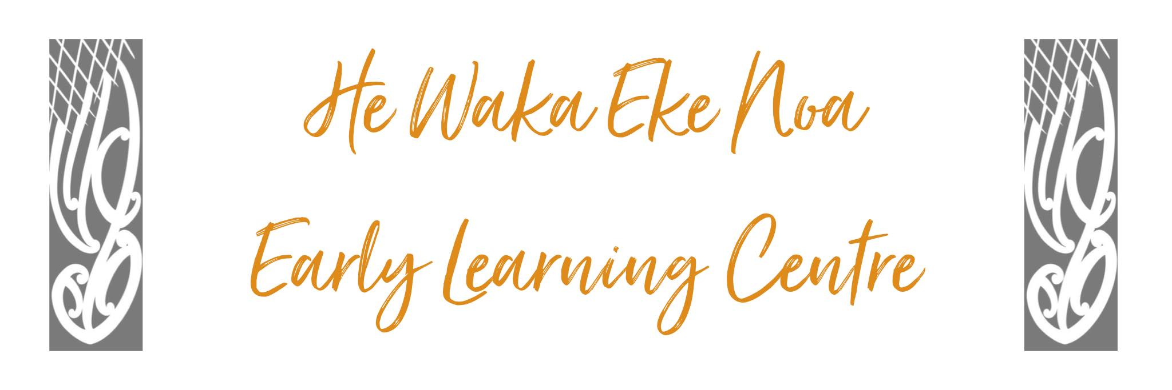

Substance Abuse Policy

Policy: Children and staff will be protected from the influences of substance abuse and from behaviors of those under the influence of mind-altering substances including drugs and alcohol.

Procedures:

- No person will use alcohol or any other mind-altering substances while at the Centre.

- Any staff member reporting for work under the influence of alcohol or any other illegal substance will be immediately suspended and asked to leave the Centre.

- Formal disciplinary procedures as laid out in individual contracts will begin.

- Any other person e.g., (visitor, student, etc), under the influence of alcohol or other illegal substances, will be asked to leave and if they do not do so immediately the Police will be asked to remove them.

Date: | November 2024
Review Date: | November 2025
Consultation  Undertaken: | Staff/whanau/community

Links to: Licensing Criteria HS33

