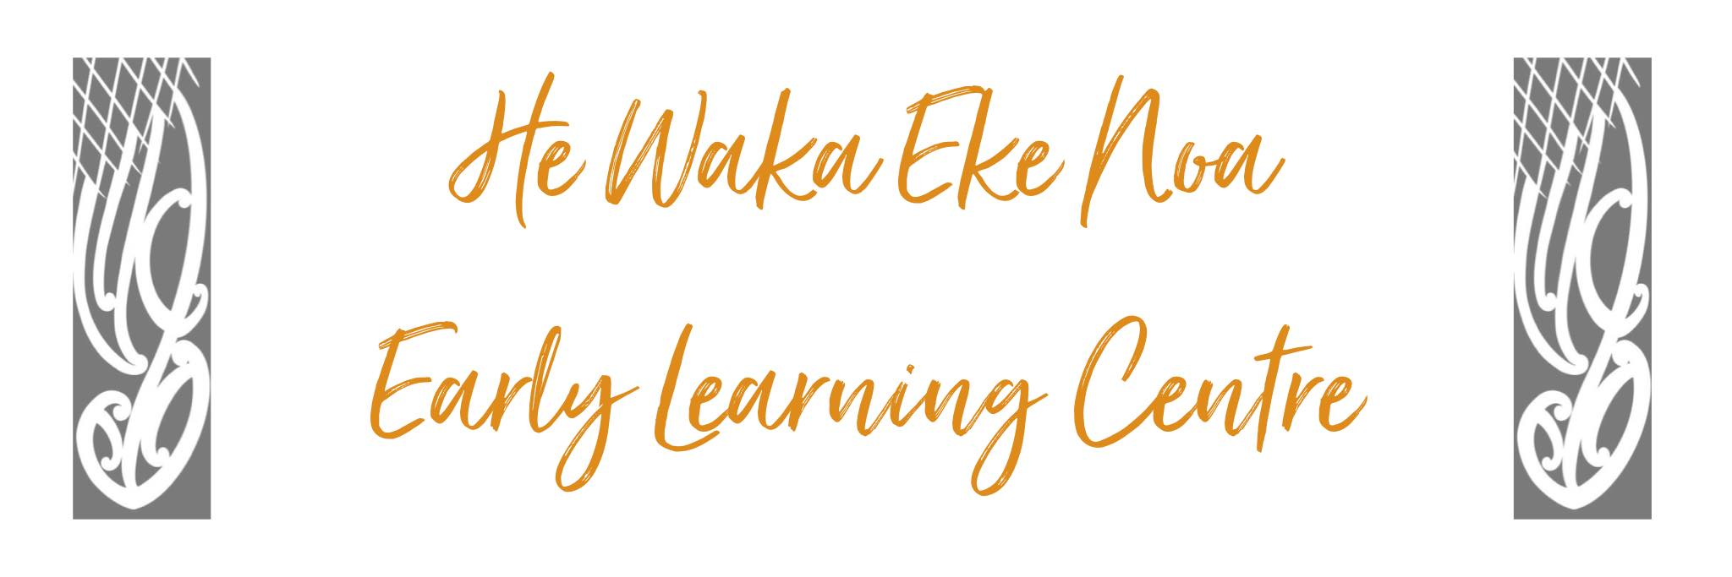
Sun Safe Policy

Policy The Centre will ensure that all children and staff are protected from detrimental exposure to the sun through the provision of shade, availability of Cancer society approved SPF50+ sunscreen, hats and through sun safe education.

Procedure

- Sunscreen and sun hats will be required by children and staff to be worn outside throughout the months of daylight saving (October – March). The Centre will provide SPF50+ sunscreen. If any child has any intolerance of common sunscreens their parent/whanau will be asked to provide for their child’s needs.

- Staff will record on outside signing sheet or in the app to ensure sunscreen application at least three times over the day.

- The Centre will have a supply of spare hats available for children’s use.

- Parents will be asked to provide their children with appropriate swimwear. i.e Sleeved rash shirts for full coverage.

- Umbrellas and shade sails are established and will be maintained to ensure shade areas are available with appropriate activities and seating.

- Children will be encouraged to move into shade or indoors whenever they wish.

- Children will be encouraged to drink plenty of fluids through use of the water filter and kitchen supplies.

- The Staff Member on outside each day will be responsible for Sun blocking / Hats assisted by the Toilet and Float person. A team approach will be used on days that we are full.

- Ongoing Sun Safe education will be delivered when applying sunscreen, looking at keeping ourselves healthy programmes and by excellent adult role modelling.

Date: | January 2025
Review Date: | January 2026
Consultation  Undertaken: | Staff/whanau/community

Links to: Regulation 46

