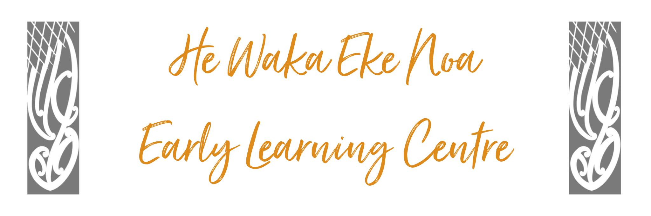

Te Tiriti o Waitangi Policy

Policy:
This Centre honours the promises made at the signing of
Te Tiriti o Waitangi and acknowledges Māori as Tangata Whenua of Aotearoa
New Zealand.

Procedure:

- The Centre kaupapa is underpinned by Te Ao Māori practices embracing Te Reo Māori me tikanga Māori world views. Reflecting a Te Ao Māori world view is an integral component of the programme.

- Tamariki will have opportunities to experience, participate and practice all aspects of their own and each other’s culture including music, stories, art and craft, visits, visitors and community events.

- Management will support cultural experience and practices by ensuring there are relatable adults implementing the programme, and appropriate, authentic equipment and resources are available to support children’s learning and experiences. These resources will include pukapuka, waiata, art works, puzzles, natural materials, and any other resource that may be useful.

- All Staff will be expected and encouraged to practice and normalise the use of Te Reo Māori and respect the practices of Tikanga Māori in all aspects of centre life.

- Professional development delivered by Māori practitioners will be encouraged for staff and management to build their personal confidence in complying with the requirements of this policy.

- All teachers, tamariki and whanau will be supported to stand strong in their own sense of mana this is reflected throughout our core values, Manaakitanga, Kaitiakitanga, whakahanaungatanga, Kotahitanga and Rangatiratanga.

Date: | November 2024
Review Date: | November 2025
Consultation  Undertaken: | Staff/whanau/community

Links to: Licensing Criteria C5, C6

