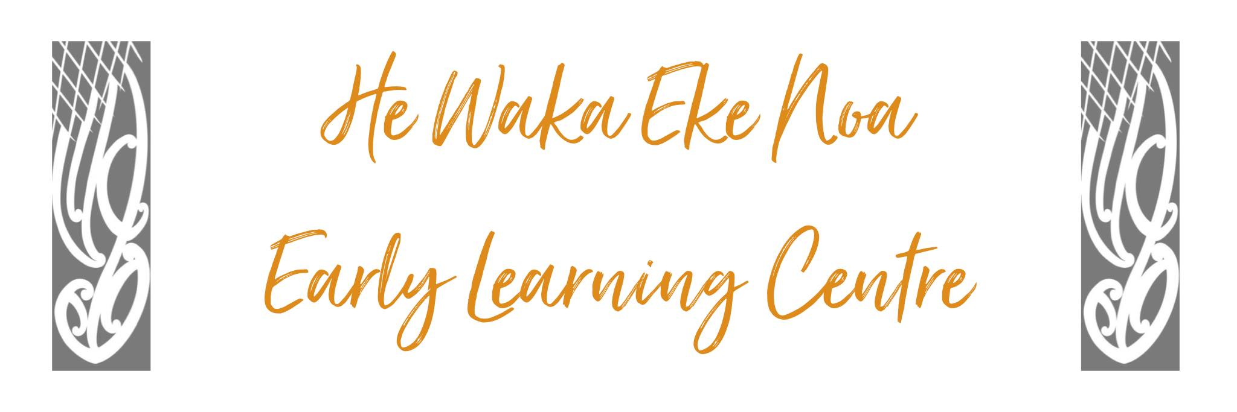

Visitor Policy
Purpose:
Children’s safety is paramount at all times. The centre undertakes to ensure, as far as possible, that no visitor poses a risk to any child or adult in the centre.
Procedure
- All visitors to the Centre will sign in on the tablet when they come into the centre and sign out when they leave. The tablet will prompt them for the relevant information and contact details should we need to contact them in the future.

- There may be times when a child who is not enrolled visits a centre, accompanied by their parent or another adult. A visiting child of any age must be counted towards regulated adult-to-child ratios and licence maximum requirements while they are present at the centre during licensed hours. An adult or parent attending with a visiting child can be counted as an adult in regulated adult-to-child ratios for the purpose of supervising their visiting child.

- Senior staff will be responsible for ensuring visitor signs in and that the evacuation procedures are explained clearly to them and that safety exits and meeting areas are identified.

- At no time will any visitors be left alone with any children

Date: | October 2024
Review Date: | October 2025
Consultation  Undertaken: | Staff/whanau/community

Links to: Licensing Criteria HS33

