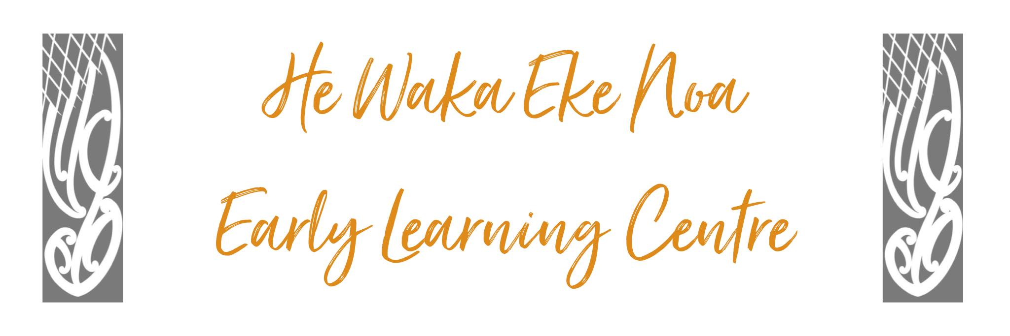

WASHING OF SICK/SOILED CHILDREN
The purpose of this operational procedure is to ensure that a child's dignity is maintained at all times and hygiene and infection control outcomes are met in alignment with Licencing Criteria PF26.

Position Statement – Tamariki will
We will ensure that all reasonable steps are taken to prevent the spread of infection among children and staff at the Centre. Our Centre provides a procedure for washing sick or soiled children which promotes high standards of hygiene, health and safety. Children’s comfort and well-being is a priority in our Centre practices.

Issue Outline
Following this procedure will reduce the risk of the adult washing the child being infected and ensure there is no cross-contamination or spread of infection to other adults or children. Following this procedure will promote consistency of practice between staff.

Alignment with Policies
This procedure aligns with the following Centre Policy:
- Nappy Changing Policy
- Nappy Changing Facilities
- Infectious Disease/Illness Policy

Procedure Detail
Step | Procedure
 | Adult to use gloves and any protective clothing provided by the Centre to remove soiled clothing, seal in double plastic bags or into a red bucket with sanitiser specifically for that purpose
 | Adult to wash the child using the facilities provided and using a disposable cloth or a cloth specific for the task
 | Adult to put on clean gloves, child to be dried and dressed in their own spare clothing
 | Adult to use bathroom specific spray made up to a 0.1% solution of bleach and water or disinfectant that has .5% sodium hypochlorite in it to clean the area.
 | Use disposable cleaning equipment if possible, e.g. cloths and mop heads. If using a re-usable mop, soak in 0.1% bleach solution after use for at least 30 minutes. Use separate cloths for high risk areas specific for the task e.g. toilet and bathroom.
 | Pay closest attention to areas of likely contamination and hand contact surfaces, for example toilets, bathroom floors and walls (especially the area surrounding the toilet after vomiting and diarrhoea), doorknobs, sinks, taps, benches, hand rails and light switches.
 | Towel/cloths used to be placed in washing machine separate from any other items on a hot wash
 | Towel/cloths used to be placed in washing machine separate from any other items on a hot wash
 | Wash hands thoroughly using warm water and soap, dry using paper towels, follow up with an alcohol-based hand sanitizer if available

Relevant Background (including Legislation/Regulation/Licensing references)
Licencing Criteria 2008, Premises and Facilities
- PF26: There are suitable facilities provided for washing sick or soiled children and a procedure outlining how hygiene and infection control outcomes will be met when washing sick and soiled children.

Implementation
Clear processes and procedures have been developed and staff trained to follow them.

Review
Review annually or when there is a significant change in the area of the policy topic or the procedure.
Date: | June 2024
Review Date: | June 2025
Consultation Undertaken: | Staff/Whanau/Management Committee

